Final Report  
One Card Transit

short line

**Keya Shah**

**Pradnya Ambre**

**Rohit Pahuja**

**Karthik Reddy**

**Hema Kotte**

5th May 2019

# **Executive Summary**

Transit system is a type of high-capacity [public transport](https://en.wikipedia.org/wiki/Public_transport) generally found in [urban areas](https://en.wikipedia.org/wiki/Urban_area).Transit companies around the world are looking to modernize and expand their fare collection systems to include alternative payment methods. The current system is tedious, time-consuming and not so user-friendly. In the case of NJ Transit, users have to buy separate tickets for bus, train, and light rail each time via online or station machines. Today’s commuters want more flexible fare payment options. Commuters don’t always have exact change or the time to purchase their fares in advance, so it’s harder for them to take public transit. The gap between traditional payment methods and consumer habits is getting wider every year. Commuters, who often use more than one [transit system](https://www.openaccessgovernment.org/more-people-choosing-green-transport-methods/2205/) to get to their destination, are frustrated with having to pay separate fares for each system. The payment solution provided in this project - a Unified Transit App (Mobile Application) makes it easier to pay fares – commuters will be much happier and public transit more accessible. Riders can simply buy their tickets through the app and no need of navigating through different transit applications. They can book all NY-NJ transit tickets through this unified transit app which can save a lot of trouble and time and will eventually lead to a simpler process.

# 

# 

# **Introduction and Background**

New York City and New Jersey have different types of transit platforms.

1. Subway which runs in New York City managed by MTA (Metropolitan Transport Authority)
2. NJ Transit (Rail, Bus, Light Rail) managed by NJ Transit.
3. Path (NY-NJ connection) which is managed by Port Authority Trans Hudson Corporation.

In the current scenario, we have to buy tickets through separate platforms if we want to ride in these transit systems.

1. Subway- Users have to recharge their MetroCard through the machine systems which are installed on subway premises and for that they need cash, debit or credit card with in order to recharge the card. Sometimes the rider is getting really late and tends to miss his/her train and they have to recharge card through the machine systems only.
2. NJ Transit - If users want to travel in NJ transit, they have to select options from the bus and train. They can also buy tickets with cash but sometimes carrying cash is too cumbersome for riders. They can’t put some amount of money in mobile wallet and currently have to separate tickets again and again.
3. For Path, users have to recharge their MetroCard by using cash, credit or debit cards.

# **Opportunity or Problem Definition**

Each weekday, people utilize public transportation thirty-five million times. Many customers want to use public transportation because of its convenience. Different bus routes and train stations are located almost everywhere, making it easier for riders to travel to and from places quickly. However, a major flaw to the public transportation is when riders have to take various transit systems on the same day. They have to buy multiple different tickets, continuously refill prepaid cards and wait in long lines during peak hours. Since riders have to explore and navigate through all these different platforms, it’s cumbersome and time-consuming.

The opportunity we are proposing is a unified transit mobile application among all the transportation companies like NJ Transit, MTA, Path, Bolt Bus, Lakeland, etc. This will ease the payment system and facilitate a better experience for the riders.

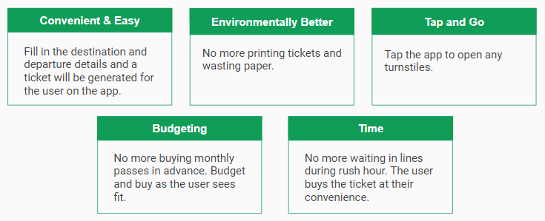

This app will have many benefits such as

1. It will be convenient and easy to use since the rider can fill in the destination and departure details and a online ticket will be generated which they can show the conductor when they board the train or bus.
2. Since no more paper tickets will be printed, it will be environmentally better.
3. For users who are taking the Subway, the tickets will be generated with a barcode so they can easily tap and go to open the turnstiles and bypass any automated security.
4. Users won’t have to buy monthly passes in advance and not use them to their full advantage. They can budget easily and buy as they see fit on how many tickets they need.
5. The worst thing for users when they are running late is waiting in line during rush hour to purchase tickets. Now they can purchase them in advance and at their convenience.

**The key stakeholders are**

1. Transportation companies- NJ Transit, Bolt Bus, Lakeland, MTA, Path, Amtrak, etc.
2. Riders who use the different transit systems
3. External vendors who will be working on creating this app- developers, testers, project managers, etc.
4. Employees of these transportation companies- conductors, drivers, security guards, etc.

# **Alternatives considered and your Recommended Solution**

# There are two alternatives that we thought of in order to improve the current system:

1. Having a unified transit card
2. Having a unified mobile app

We chose the unified mobile app alternative to the current system since it saves lot of time and eases the overall ticket booking system. The current system is tedious, time consuming and not so user friendly. The unified mobile app solves all these problems by letting all commuters enjoy the following perks:

1. **Saves time:** It saves lot of time for the commuters who travel on a daily basis by having their tickets booked well in advance before or on their way to the train station. It favors them by not having to worry about the long queues during the rush hours.
2. **User-friendly:** The mobile app will have a good interactive and smooth user interface that is easy to understand and book tickets in no time.
3. **Allows directly connecting to the bank account:** The user can connect to his bank account or enter his/her credit card details and pay directly from the card/bank account thus not having to worry about refilling the card well in advance.
4. **Safe and Secure:** All the bank transactions and sensitive user details are encrypted and customers’ privacy is ensured.
5. **Accepted at rail and bus transport facilities:** The mobile app is for most major rail and bus transport facilities in New York and New Jersey, this reduces the overhead of carrying and handling multiple travel cards and worrying about refilling each of them with a specific predefined amount irrespective of the its usage.

# **Benefits Estimates and Assumptions**

Since riders have to work through the different platforms to book the tickets of Path (NY-NJ connection), NJ Transit (Bus, Rail, Light Rail), MTA (NYC Transit) which is time consuming, our plan of a unified mobile payment application can be developed to help the transit systems. More employment can be generated as developing this unified mobile transit app requires plethora of man power like developers, testers, project managers, designers etc. Capability gap analysis involves identifying the gaps between how the current capabilities are performing in the business and how you would want them to do within a specific time frame. A team of qualified professionals will be engaged so that this proposed idea of the unified mobile app can be achieved successfully. Drafting a schematic plan for the coordination among the management of Path (NY-NJ connection), NJ Transit (Bus, Rail, and Light Rail), and MTA (NYC Transit). Formulating a secured unified payment system for the mobile app as digital mobile payment system is vulnerable to cyber threats, hacking and other digital attacks. The payment solution provided in this project makes it easier to pay fares – commuters will be much happier and public transit more accessible.

# 

# **Cost estimates and assumptions**

There are some assumptions which have been taken while calculating the cost for this project.

|  |  |
| --- | --- |
| Cost Factor | Amount |
| Resources   * 100 employees working 40 hours per week who are taking approximately $30 an hour working for 4 weeks in a month   (Hours x Wage/hour) x Weeks x Months x Employees | $5,760,000 |
| Hardware cost  -installing servers, data centers, network devices like routers, switches, bridges, hub, repeaters, etc | $200,000 |
| Infrastructure cost  -electricity, office costs and other utilities like internet, food, etc | $1,000,000 |
| Scanners cost | $500000 |
| **Total cost** | **$7,460,000** |

# **Risk factors and Mitigation**

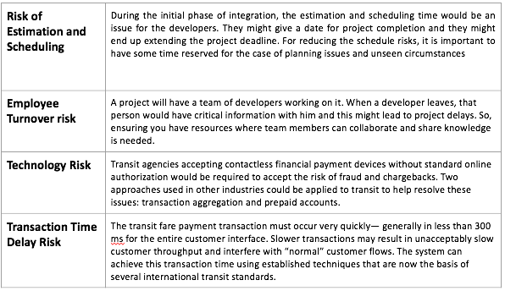

# **Implementation Timeline**

We have estimated that the project would take a year to complete. Project development involves several stages. The first stage would be Research and Development. Initially, during the research phase, the key elements would be identified, and the team would collaborate on different application features that will work together to meet the system requirements. Discussions would be made regarding the desired look and feel of the application. Decisions regarding the features being built in the initial release and the later releases would be discussed. The Second phase would be Planning Architecture & Development. In the Planning phase we would be laying all the tasks in order and assigning the resources and we would be seeing which tasks would go together. After planning, technical architecture defines the technologies which we will use. And a large amount of time would be spent on coding the application. And the final step would be software testing. Depending on the project, there are several tests which have to be done. The most common testing would be end-to-end testing and user acceptance testing. In the end-to-end testing all the features and functionality of the application would be tested. And second testing would be user acceptance testing. It’s a period of time where the stakeholders would use the application and would sign off on the development.

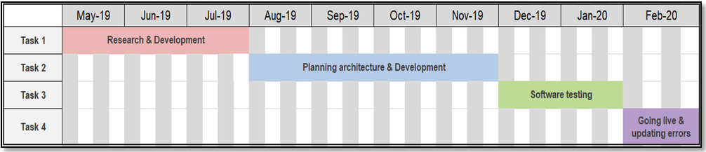

# **Appendices**

**Work Systems Snapshots (AS-IS and TO BE)**

**(AS-IS Model)**

|  |  |  |  |
| --- | --- | --- | --- |
| Customers: | | Product Services: | |
| •Customers are users who use the transit system | | •Providing tickets to access different transport services such as NJ Transit, Path, and MTA. | |
| Work Practice Goals: | | | |
| •The users purchase ticket at one of the transit station.  •The users can pay in cash, debit or credit card.  •The machine would print the ticket if the transaction is approved.  •If the user needs to switch to a different transit side, then he should purchase a different ticket following the same process as above. | | | |
| Participant: | Information: | | Technology: |
| •NJ Transit  •Path  •MTA  •Riders/Customers | •The users will have to purchase the ticket with respect to the transit system to access their service. | | •Web based data distribution systems.  •Transaction retrieval systems. |

**(TO-BE Model)**

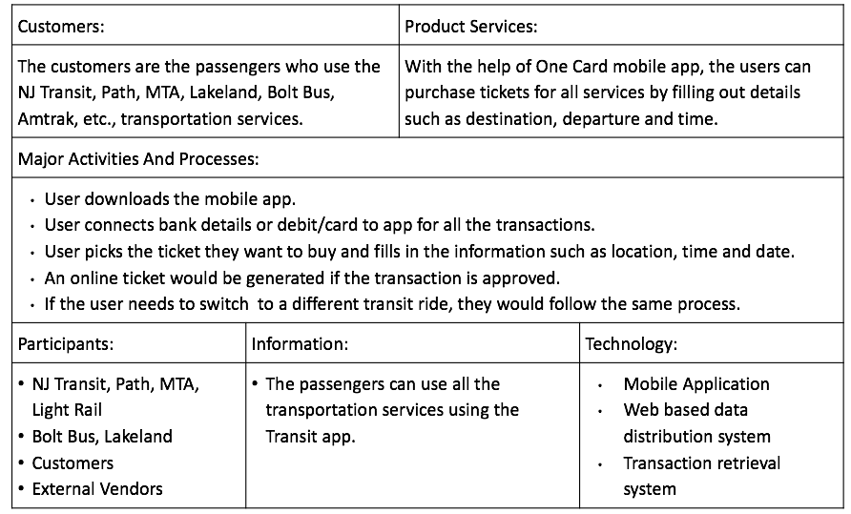

We have made some changes to the To Be section. Here the passengers can buy tickets for all the services such NJ Transit, Path and MTA using the One Card Transit Application. The users can pay for the tickets using credit or debit card. We have included transit services such as Bolt Bus, Amtrak and Lakeland. Since it’s an app, we have included mobile application in the technology column.

**BPMN Diagrams (AS-IS and TO-BE)**

**(AS-IS Model)**

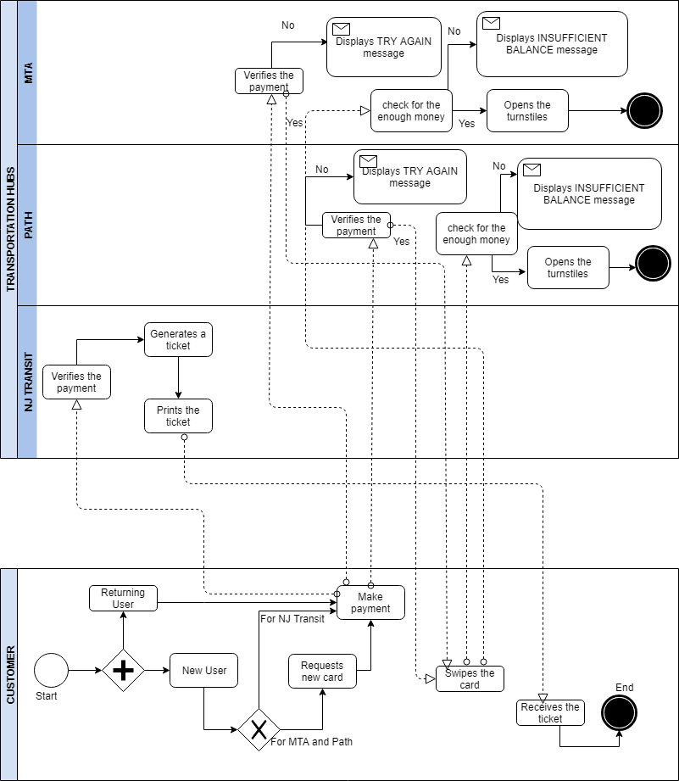

The high level process diagram (AS-IS) reflects how the current system works. In the current system the commuters have to purchase and manage different cards for the PATH and New York Subway and worry about refilling them from time to time with a predefined amount irrespective of their usage. This might lead to wasting some amount if not utilized before the expiry date.

In the current system, for the commuters of MTA and PATH-

1. A **new commuter** has to purchase the metro card and pay through the machines at the subway station.
2. The MTA and PATH verify the payment and if valid issue a new card to the user with a certain predefined amount as certified by the commuter.
3. After this the user can then swipe the card and is then charged the money and let in through the turnstiles.
4. If the user doesn’t have enough balance then an error message showing ‘Insufficient balance’ is displayed.
5. The **existing user** follows all the steps from 3 to 4 and in case of insufficient balance refills the card by refilling the card following the step 2.

**(TO-BE Model)**

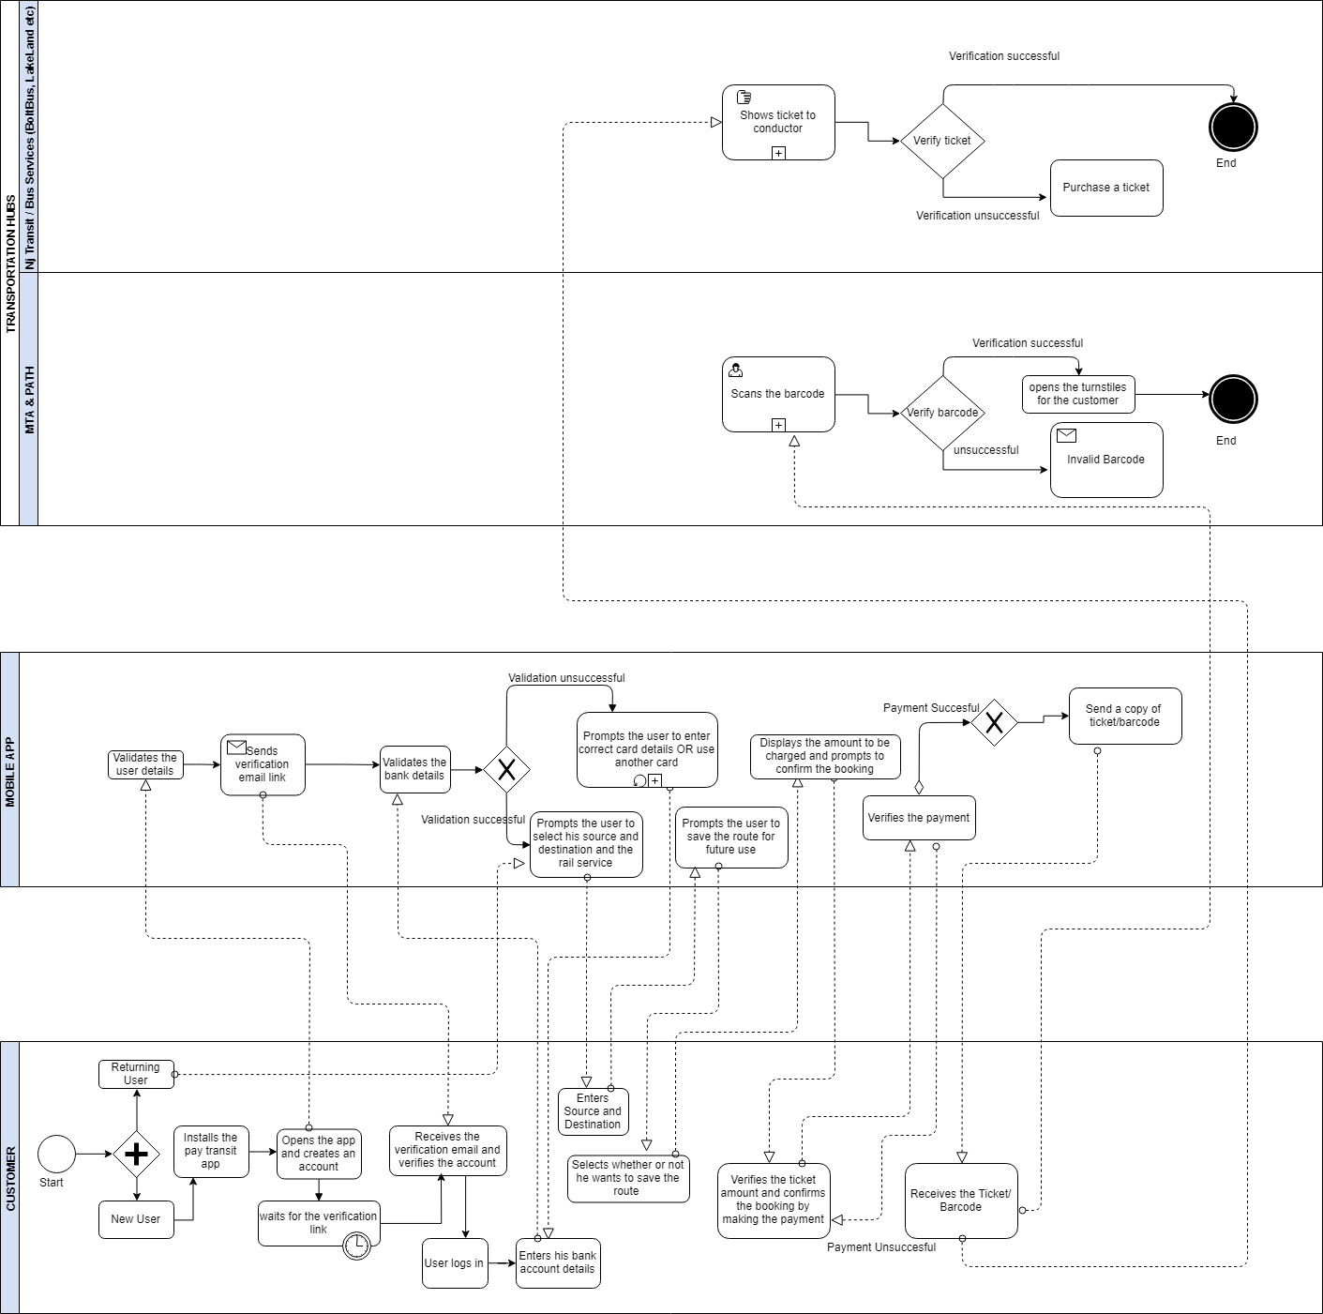

The high level process diagram for the To-Be introduces the mobile app as a middle-level and most of the tasks that earlier were a part of the MTA/PATH and NJ Transit/Buses are now taken care of by the online automated mobile app, completely safe, secure, user friendly and efficient in terms of performance.

1. The **new user** installs the app, fills in their personal details, and connects to his/her bank account by entering the bank details.
2. Enters the source and destination and pays the money to purchase the ticket.
3. The mobile app backend charges the money to his bank account and generates a barcode/ticket in the mobile app itself. (The app generates a ticket for NJ Transit and saves it in the app, which can be viewed in the offline mode, so that the customer can show it to the conductor and it generates a barcode that the MTA and PATH users can tap and go at the train station.)
4. The **existing users** directly open the app and follow steps 2 to 4.

**Scoping Diagram**

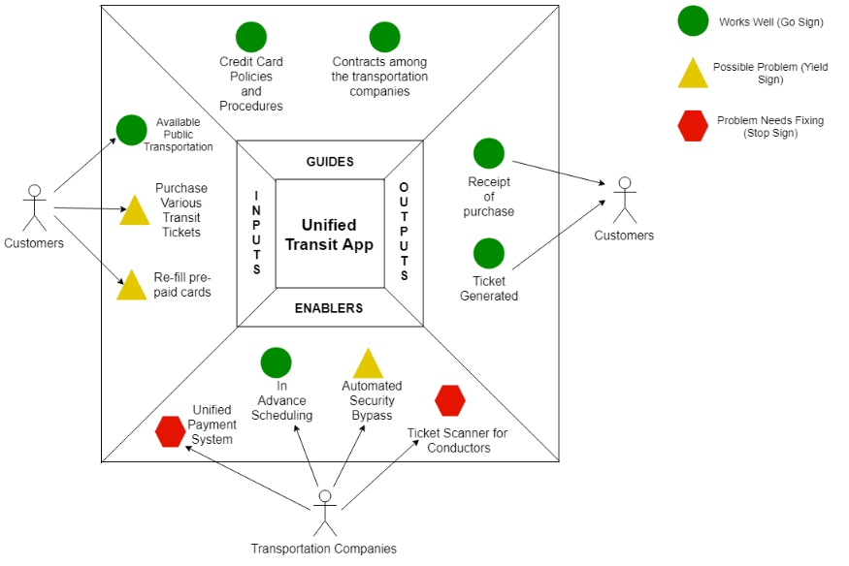

Inputs

1. Works Well- there are enough public transportation options available for commuters.
2. Possible Problems- Users have to purchase various transit tickets if they need to travel in different systems on a daily basis. Users also need to refill prepaid cards or buy new ones if the cards have expired.

Enablers

1. Works Well- Users can go online and buys tickets in advance from different transit websites.
2. Possible Problems- Users sometimes need to bypass automated security like turnstiles in the subway.
3. Problems Need Fixing- Need a unified payment system to help ease the commute of riders. Since we plan to generate tickets online, the companies will need to invest in creating scanners for the conductors on buses and trains to make the ticket is valid and not being re-used.

Outputs

1. Works Well- Users get a ticket and confirmation that their ticket was purchased for security purposes if they were to lose one or the other.

Guides

1. The companies will need to honor the contracts they draft up to make the unified mobile app system work as well as following the credit card policies and procedures for secure transactions.